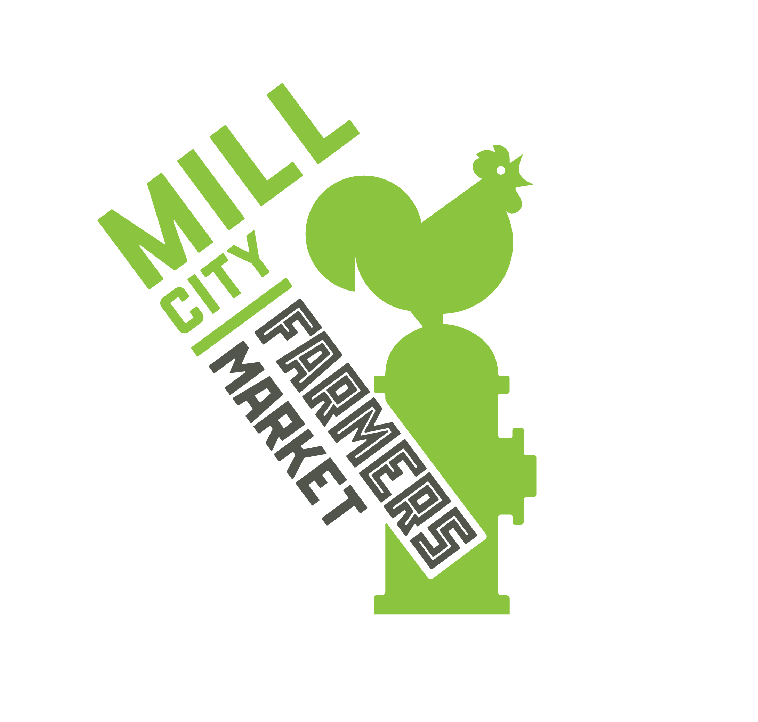
Mill City Farmers Market – New Vendor Pre-Application

Thank you for your interest in vending at the Mill City Farmers Market. We are not currently accepting new vendors. Our applications open each season at millcityfarmersmarket.org/become-a-vendor between mid-December and mid-January.

If you are interested in selling at Mill City Farmers Market in the future, please fill out the application below, and email it to info@millcityfarmersmarket.org.

Today’s Date:

Vendor Information:
Your Name | Business Name
Business Location | Farm, Kitchen, or Studio Location (if different)
Phone Number | Email
Business Website | Business Social Media

Please list the products you offer and their price points:

How long have you been in business?

Have you sold at other farmers markets? If so, which market(s)?

Please describe what makes your products unique and desirable/saleable:

Please describe the role of “sustainability” in your business and how you meet the Market’s Sustainability Statement.

Do your products meet our Local Sourcing Standard, meaning at least 25% of ingredients/materials are sourced from local farms? If no, please describe why not and if local sourcing is something your business is interested in pursuing.

At which of our markets are you interested in vending? Note: we typically reserve our limited winter market spaces for year-round vendors.

- Outdoor Saturday Market (May through October, 8 a.m. – 1 p.m.)
- Indoor Winter Market (select Saturdays November through April, 10 a.m. – 1 p.m.)

Is there anything else we should know about your business?

Thank you for taking the time to complete our pre-application. Please email this completed form to info@millcityfarmersmarket.org. While we typically do not accept new vendors outside our winter application period, we will be in-touch if anything becomes available this season.

