Mill City Farmers Market Contact:
Jenny Heck, Marketing and Events Manager
jenny@millcityfarmersmarket.org, (763) 308.3662
www.millcityfarmersmarket.org
April 27, 2018
FOR IMMEDIATE RELEASE: New season, new vendors
Get ready for the outdoor season at Mill City Farmers Market—opening Saturday, May 5th!
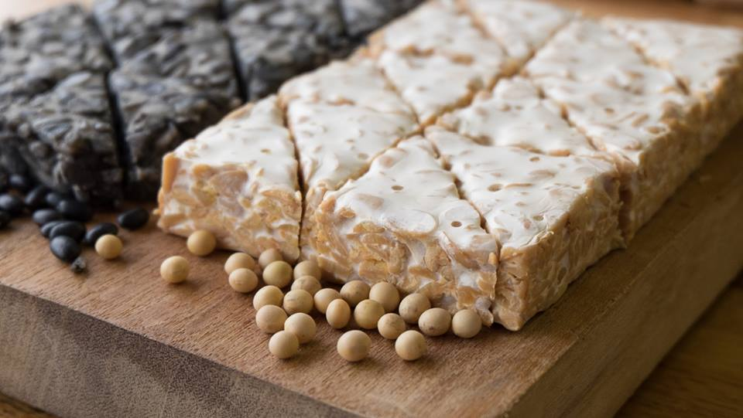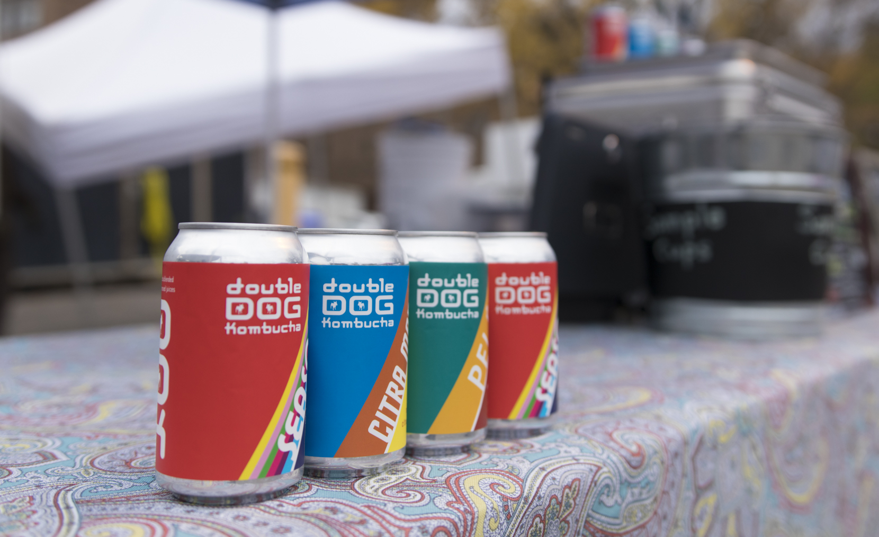
Minneapolis, Minn.—On Saturday, May 5th Mill City Farmers Market (MCFM) opens for its 13th season. Grab your favorite tote bag and your grocery list and get ready to shop the market’s curated assortment of over 130 farmers, food makers and artists. This season, the downtown local and organic grocery hub is welcoming 21 new vendors. Just like long-time vendors at the Mill City Farmers Market, new comers follow the market’s Sustainability Statement, ensuring all products at the market—from hand rolls of sushi to a can of jalapeño ginger kombucha—are grown and sourced with the health of our land, local economy and people in mind.
“The 2018 Mill City Farmers Market season is Tempeh Tantrum's first farmers market ever!” Says Ryan Billing, owner of Minneapolis-based plant protein company Tempeh Tantrum. “I'm very excited for the opportunity to accompany my tempeh out of the kitchen to meet new and existing customers—as well as to connect with those with even just a passing interest in what I'm offering. So jazzed to be part of the MCFM crew this year!“
You can meet Ryan and MCFM’s other new vendors (listed below) May through October at the Saturday Market, in between the Mill City Museum and Guthrie Theater, and at the new Tuesday Night Market from June through September at The Commons Park, a 4-acre green space next to U.S. Bank Stadium.
In 2017, these two markets drew over 115,000 local food enthusiasts, who enjoyed not only the wide assortment of vendors but also the market’s vibrant and educational programming—including chef-led cooking demonstrations, farm-to-table breakfast, dinner & lunch from local restaurants and food trucks, free outdoor yoga classes at every market June through September, live music and so much more! Get your shopping list ready by browsing the list of new vendors joining the MCFM line-up this year.
New Vendors at the Mill City Farmers Market in 2018
Prepared Food:
- Gohan Sushi – Hand rolls of traditional Japanese sushi with a Midwestern twist
- Green Garden Bakery – Vegetable-based baked goods from Heritage Park youth farmers and entrepreneurs
- Root to Rise Kitchen – Vegan breakfast and lunch, ranging from tofu veggie scramble to jackfruit tacos

Farmers:
- Northerly Floral – South Minneapolis based flower farm
- Red Clover Herbal Apothecary Farm – Salves, tinctures and herbal teas grown and made on the farm in Amery, Wisconsin.
Food Makers:
- Best Cellar – Pickled vegetables and mushroom jerky
- Bhavana Organics - Organic beauty products and natural remedies
- Caldo Foods – Harissa, chimichurri and other Mediterranean-inspired sauces
- Crunchy Granola – Minneapolis-based granola company
- Double Dog Kombucha – Unique flavors of kombucha (mango citra hops, pineapple ginger jalapeño cilantro, and seasonal) served on tap and in cans
- Señoras de Salsa – Authentic Mexican salsas that empower Latina women
- Tempeh Tantrum – Plant-based protein made from fermented soy, black bean and seasonal ingredients
- Well-Rooted Teas – Loose-leaf herbal teas blended with foraged botanicals. 10% of profits benefit organizations working to protect our environment
Artists:
- CardFolk – Greeting cards highlighting culture with a fashionable flair
- Create Laser Arts – Laser engraved goods and handmade functional wares in wood, paper, leather, stone and acrylic
- Furniture by DeGarmo – Woman-owned and operated wooden furniture and home furnishings
- Onkkafirte – Handcrafted, custom made lazy susans
- Radiate Activewear – Locally designed and produced athleisure wear
- Sudify Jewelry – Jewelry made with lichens, moss, leaves, ferns and more, showing the beauty of the natural world
- United Goods – Prints, bags, cards and more featuring iconic local landmarks
- Vikse Designs – Handmade semi-precious stone and sterling silver jewelry

Founded in 2006 by acclaimed local restraunteur Brenda Langton, Mill City Farmers Market is Minneapolis’ trusted source for healthy, local and organic groceries, bringing a wide assortment of fresh food, cooking education and live entertainment to three beautiful downtown spaces. The Saturday Market is located next to the Guthrie Theater on 2nd Street S. and Chicago Avenue S. May through October, the new Tuesday Night Market is in The Commons Park next to U.S. Bank Stadium June through September and the Indoor Winter Market is inside the historic Mill City Museum on select Saturdays November through April. Learn more at millcityfarmersmarket.org ###

