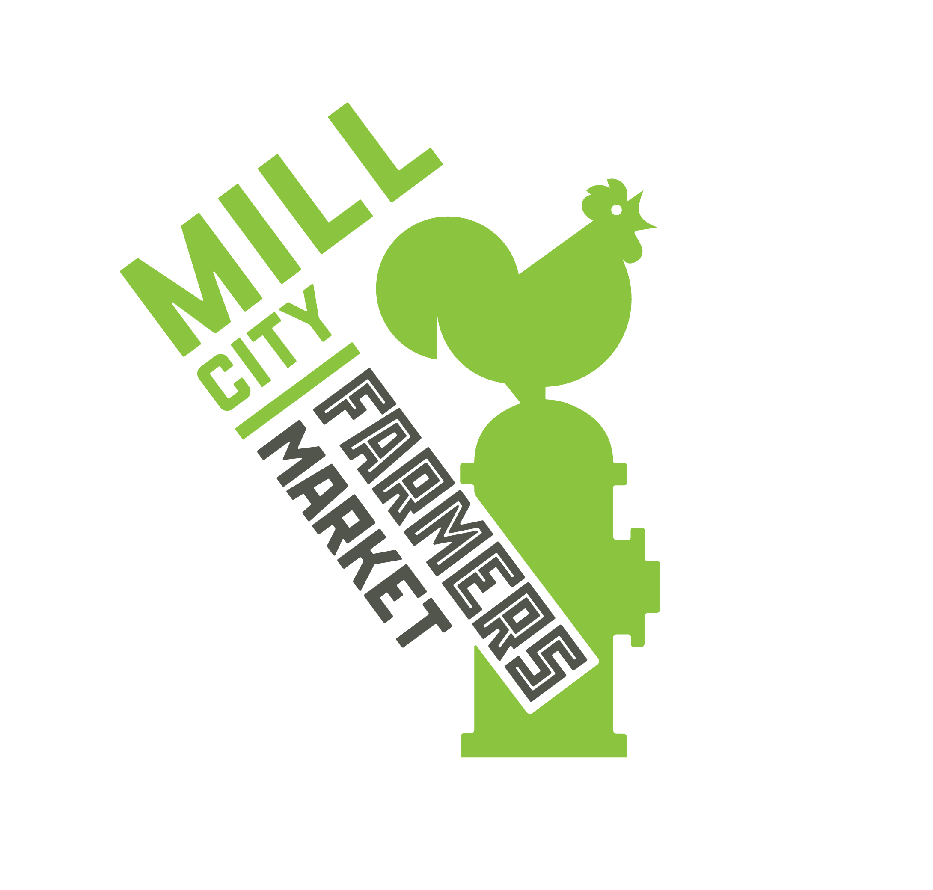
Mill City Farmers Market – New Vendor Interest Form

Thank you for your interest in vending at the Mill City Farmers Market. We are not currently accepting new vendors– our outdoor season applications open annually from mid-December until mid-January. Learn more at millcityfarmersmarket.org/become-a-vendor

If you’d like to tell us more about your farm or business, email this interest form to info@millcityfarmersmarket.org. Please note that this is NOT an application, and that you will still need to apply during our open application period if you're interested in joining us next season.

Today’s Date:

Vendor Information:
Your Name | Business Name
Business Location | Farm, Kitchen, or Studio Location (if different)
Phone Number | Email
Business Website | Business Social Media

Please list the products you offer and their price points:

How long have you been in business?

Have you sold at other farmers markets? If so, which market(s)?

Please describe what makes your products unique and desirable/saleable:

Please describe the role of “sustainability” in your business and how you meet the Market’s Sustainability Statement.

Do your products meet our Local Sourcing Standard, meaning at least 25% of ingredients/materials are sourced from local farms? If no, please describe why not and if local sourcing is something your business is interested in pursuing.

At which of our markets are you interested in vending? Note: we typically reserve our limited winter market spaces for year-round vendors.

- Outdoor Saturday Market (May through October, 8 a.m. – 1 p.m.)
- Indoor Winter Market (select Saturdays November through April, 10 a.m. – 1 p.m.)

Is there anything else we should know about your business?

Thank you for taking the time to complete our New Vendor Interest Form. Please email this completed form to info@millcityfarmersmarket.org. While we typically do not accept new vendors outside our application period, we will be in touch if anything becomes available.

