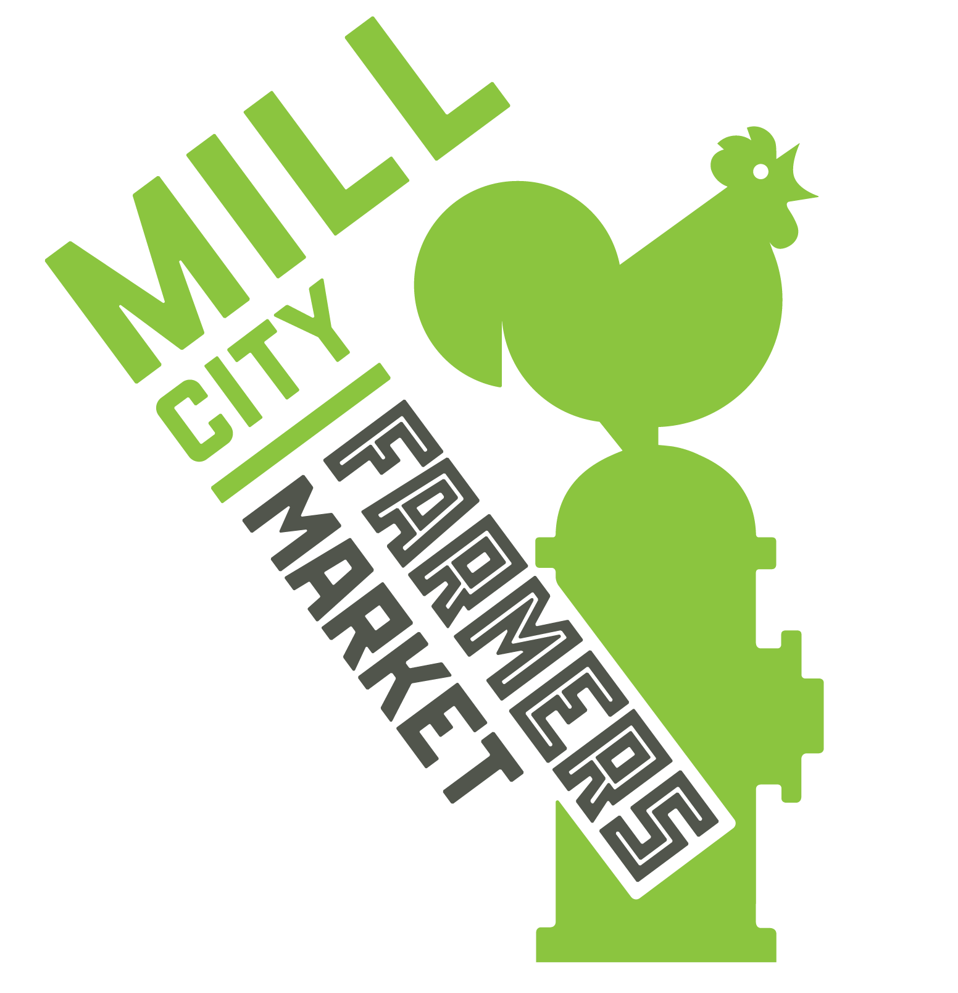
Ingredient Sourcing Form

For every product you are applying to sell at the market, list each ingredient and where you source it from. Add more space or another page if needed. Please be specific with which farms you are sourcing each local ingredient from, and list the % by volume each ingredient is in relation to the final product. If you grow the ingredient yourself, please still note that.
We reserve the right request the full recipe.

All vendors wishing to sell edible products at MCFM (with the exception of produce) must provide samples to the Vendor Product Review Committee upon request of the market managers before acceptance into the Market. All products will be reviewed by the committee according to the same criteria and standards.

Who prepares your products?

Where are your products prepared? (include address)

Menu Item | Ingredients | Source Name  (farm, store, maker name) | Certified Organic? | What % by volume of the final product is this ingredient | Price per unit sold | Size per unit sold  i.e oz, g/kg, lbs | Months product is available?
Menu Item | Ingredients | Source Name  (farm, store, maker name) | Certified Organic? | What % by volume of the final product is this ingredient | Price per unit sold | Size per unit sold  i.e oz, g/kg, lbs | Months product is available?
Menu Item | Ingredients | Source Name  (farm, store, maker name) | Certified Organic? | What % by volume of the final product is this ingredient | Price per unit sold | Size per unit sold  i.e oz, g/kg, lbs | Months product is available?

