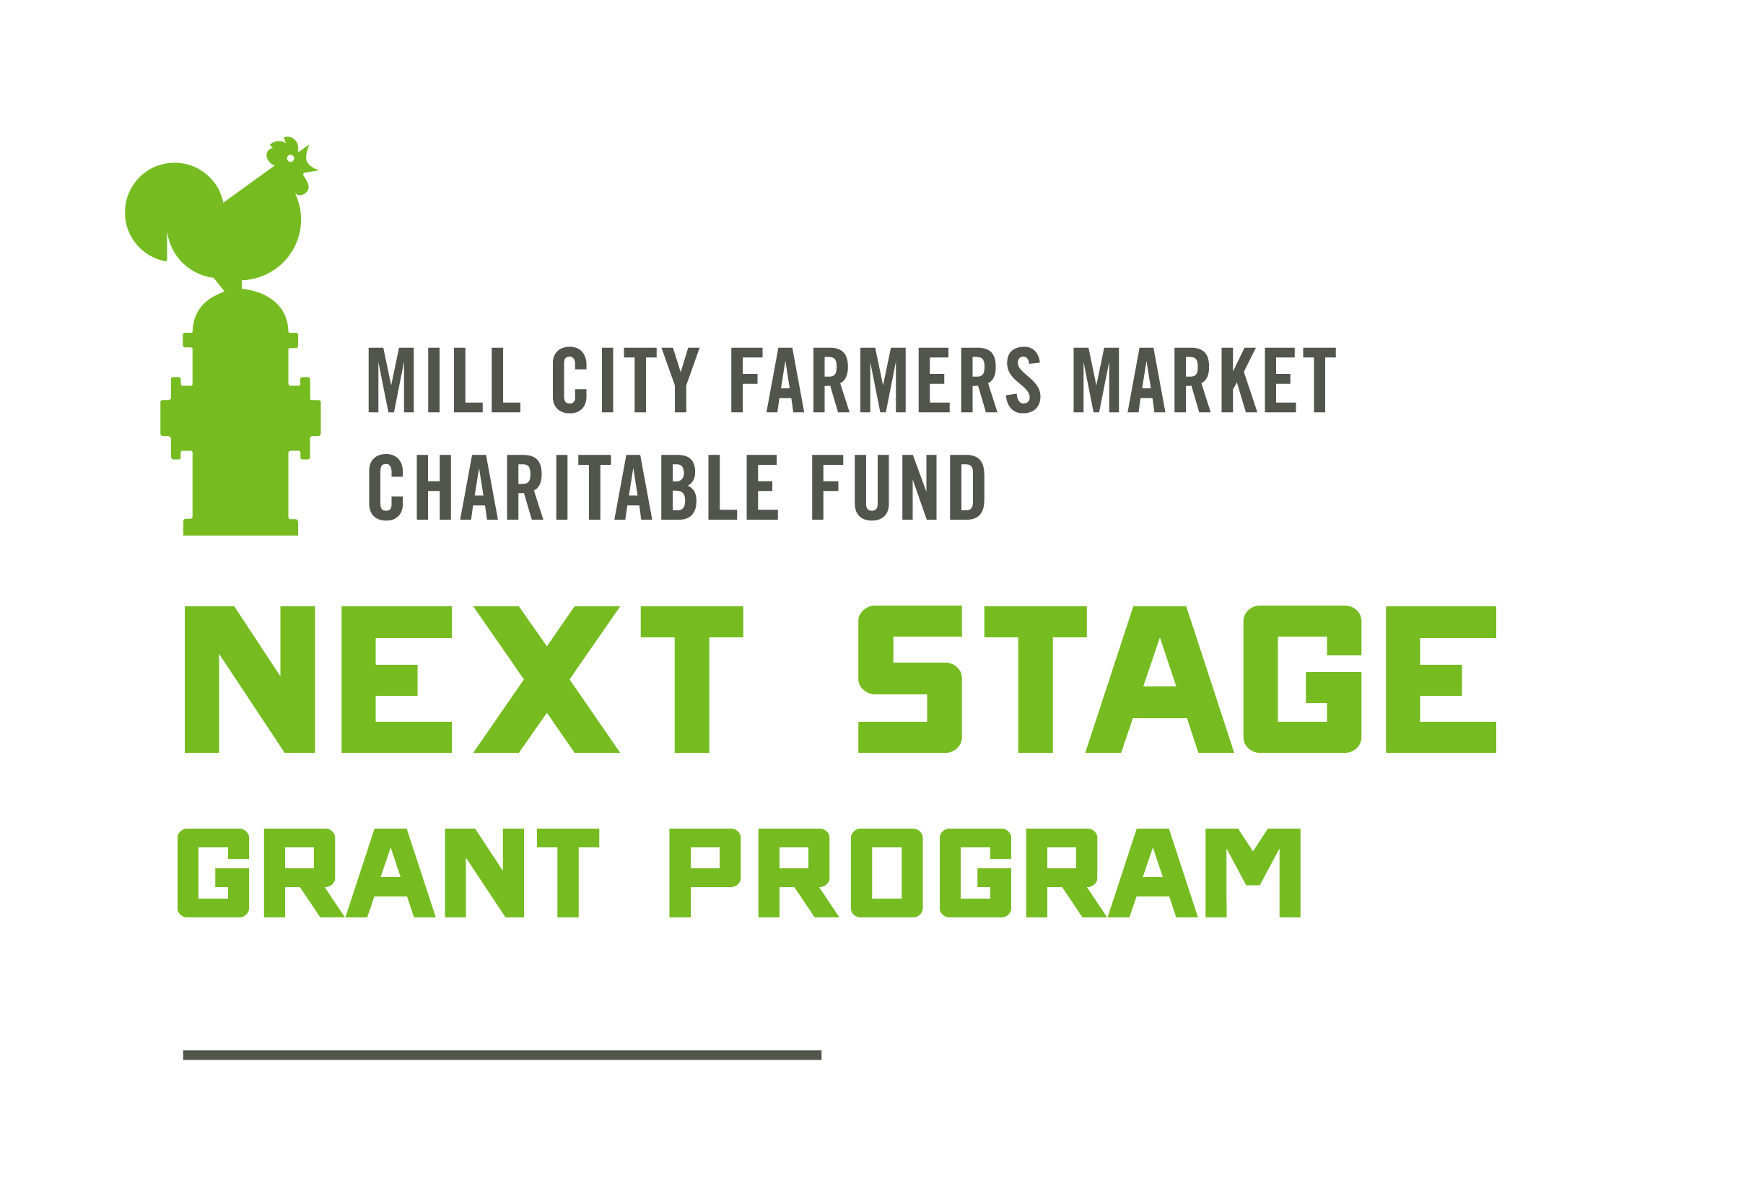

Hardship Grant

The Mill City Farmers Market Charitable Fund (MCFM-CF) is committed to the success and sustainability of the local food economy. In addition to supporting farmers and food makers who are innovating and moving to the “next stage” of their businesses through our main grant program, MCFM-CF understands that the livelihood of a farm can be vulnerable to an array of extreme weather-related crop loss or other unpredictable causes of hardship. While these risks are inherent to farming, MCFM-CF’s Hardship Grant is intended to provide support of up to $2,000 while farmers work to recover and rebuild.

This grant program is sustained through the generosity of the market community with a goal to keep regenerative family farmers on the land, producing nourishing food for all.

Application Process:
This grant is meant to be easily accessible for busy, hardworking farmers and small business owners. MCFM-CF staff is available to answer your questions, help you complete the application and will provide translation if needed. For questions or assistance with your application, please contact us at info@millcityfarmersmarket.org or 612-341-7580.

Applicant Requirements:
- Farm or business must sell at one or more regional farmers markets. Preference will be given to applicants with a higher percentage of sales coming from direct-to-consumer sales.
- Farm or business must be located within 200 miles of Minneapolis or in Minnesota
- Farms and businesses must adhere to Mill City Farmers Market’s Sustainability Statement or the project must aim to bring them closer to meeting it.
- Farm or business must have been in operation for more than one year
- Not required to be a current vendor at the Mill City Farmers Market
- Farms structured as 501(c)3 nonprofits are eligible to apply as of 2022
- Current members of MCFM-CF’s Next Stage Grant Program Selection Committee and their family are not eligible to participate in the Next Stage Grant Program

Hardship Grant program uses can include (but are not limited to):
- Financial assistance to offset loss of sales due to extreme and unpredictable crop loss from disease, pests, weather and other similar causes.
- Support rebuilding infrastructure (barn, greenhouses, etc.) after extreme and unpredictable weather events, fire or other similar causes.
- Help for farmer to stay on the land with training related to capacity-building and sound business practices from professional service providers or qualified consultants (other farmers, marketing specialists, web designers, etc.)
- Build and support resilient systems of regenerative agriculture in the face of climate change and increasing patterns of extreme weather
- Financial assistance due to loss of income, staffing challenges, increased expenses and/or other considerations related to the COVID-19 pandemic

Grantee Expectations:
- Contact with MCFM-CF staff at least once within 12-months of receiving the grant through a phone call or email to report on progress, results or other applicable confirmation of grant funding
- MCFM-CF may ask grantees to contribute to future Next Stage Grants through grantee mentorship or serving on the review committee.

Evaluation
MCFM-CF staff and board members review hardship grants on an ongoing basis, consulting with MCFM-CF’s Grant Review Committee (made up of MCFM-CF board members and staff, local farmers, former grant recipients and other local food community leaders) as needed.

Grant Amount
Up to $2,000.

Timeline
- Application Due Date: Ongoing, based on need
- Grant Award Date: Ongoing, generally within 2 to 4 weeks of applying.

Hardship Grant Application

Name:
Phone Number: Email:
Farm/Business Name: Year Established:

Business Structure:
☐LLC
☐Sole Proprietorship
☐Cooperative
☐Partnership
☐501(c)3 Nonprofit
☐Other:

If business is owned by multiple parties, please describe. Who are additional parties and what is percent ownership of each?

Farm/Business Address:

Mailing Address, if different:

Farmers, please note whether you own or rent your land and the length of lease if applicable:

Short description of your farm or business:

Description of Hardship:

Total Request (Maximum award is $2,000): $

How will this grant help alleviate your hardship?

Have you applied for or received other support to alleviate this hardship, such as: insurance payment, donations, crowd funding, other grants? If so, please describe.

Describe the role of sustainability in your business, including any relevant certifications (USDA Organic, Certified Naturally Grown, etc.) or describe your agricultural, land management and/or sourcing practices.

Tell us about your journey into farming or business ownership. What is your previous experience in this industry? Be sure to note if there is an immigration story or other relevant information.

Where do you sell your products? Please be specific.

What percentage of your sales come from farmers markets? %
From other direct marketing? (CSA, on-farm sales) %
From wholesale or other outlets? (Restaurants, co-ops, schools) %
=100%

What percentage of your adjusted gross income from your most current tax return is from your farm?

What percentage of labor do you contribute to your farm? Who else contributes to the success of your farm?

How did you find out about the Next Stage Grant Program?
☐From a former grant recipient
☐Facebook or Instagram
☐Mill City Farmers Market email or website
☐From another organization (SUSTAG listserv, HAFA, SFA chapter, conference, Extension, etc.):
☐Other:
☐Don’t remember

You will need to submit a a completed copy of the NSG Financial Summary spreadsheet with this application. You can find it on our website, millcityfarmersmarket.org/grants

Optional Demographic Information:
MCFM-CF is committed to supporting farmers who have experienced institutional barriers to economic opportunity. Please take a moment to complete the following demographics questions.

NOTE: Providing this information is not required.

What are your preferred pronouns?
☐He/him
☐She/her
☐They/them
☐Prefer not to answer
☐Other:

How do you identify yourself? (Select all that apply)
☐Asian
☐Black, Afro-Caribbean or African
☐Latinx or Hispanic
☐Native American
☐White or European
☐Prefer not to answer
☐Other race, ethnicity or origin:

Including children and other dependents, how many persons were in your household from the year of your most current tax return?

What was your Adjusted Gross Income from the year of your most current tax return? (Form 1040 of U.S. Federal Tax Return)

Please feel free to share other demographic information that illustrates your identity or share an example or story of how you have experienced economic challenges based on your identity.

Confirmation
Please sign, e-sign or type your name below, confirming all information in this application and financial summary are accurate to the best of your knowledge.

Signature:

Email this completed application with your completed NSG Financial Summary spreadsheet (available at millcityfarmersmarket.org/grants) to info@millcityfarmersmarket.org or mail to:

Mill City Farmers Market Charitable Fund
704 S. 2nd St.
Ste. 510
Minneapolis, MN 55401

GP:4810-8485-1290 v2

Our goal is to focus on farms or businesses who do most of their business as direct-to-consumer sales, which are defined as goods sold directly from producers to individuals, for example: farmers markets, CSAs and on-farm sales.
The Next Stage Grant program gives preference to small farms owned by individuals, since they often have fewer resources and grants available to them compared to nonprofit organizations. However, we also recognize the important role nonprofits play in supporting farmers, especially farmers who have been marginalized and/or denied access to capital. When assessing applications from nonprofits, we review budget size of organization, fundraising ability and size of farm among other applicant considerations.
“Family” for these purposes includes an applicant’s spouse; siblings; children; grandchildren; great grandchildren; the spouses of siblings, children, grandchildren, and great grandchildren; parents; grandparents; and other ancestors.

