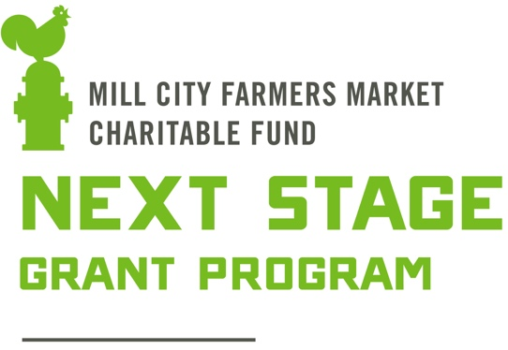
Financial Need Statement

Mill City Farmers Market Charitable Fund (MCFM-CF) recognizes that a grant to purchase depreciable property (ex., tractors, greenhouses, machinery, etc.) or to fund expenses associated with crop loss or other hardship are, standing alone, not charitable or educational. However, if the grantee can justify the need of the purchase for a charitable or educational reason, then it may be considered charitable.

Examples of charitable or educational reasons to fund these expenses include but are not limited to:
- Purchasing a hoop house to study the growth of a unique and innovative type of crop, input or growing system.
- A grantee demonstrating financial need (see definition below) and the reason(s) why the purchase of the depreciable property would alleviate that need.

MCFM-CF believes strongly in interrupting the cycle of poverty in farmers across America. We define financial need based on the federal poverty guidelines (FPG), published annually by the U.S. Department of Human Services. In 2022 MCFM-CF considers an individual to be in financial need if their 2021 Adjusted Gross Income (line 8b on Form 1040 of U.S. Federal Tax Return) was less than 275% FPG, as defined in the table below.
In situations where the grantee is an LLC, partnership or other collaborative effort of multiple parties, all parties must meet the definition of financial need.

Persons Household  Including dependents | 100% FPG | 275% FPG  Used by MCFM-CF
1 | $14,580 | $40,095
2 | $19,720 | $54,230
3 | $24,860 | $68,365
4 | $30,000 | $82,500
5 | $35,140 | $96,635
6 | $40,280 | $110,770
7 | $45,420 | $124,905
8 | $50,560 | $139,040
Data published by U.S. Dept. of Human Services January 19, 2023
https://aspe.hhs.gov/poverty-guidelines

Current methodology for the FPG was created in the 1960’s and is now widely recognized as outdated. Due to these deficiencies, MCFM-CF believes that 275% FPG is a fair definition of poverty. In fact, research suggests that, on average, families need an income of about twice the federal poverty level just to afford basic expenses. We have also considered additional criticism from the U.S. Census Bureau and NGO’s surrounding FPG, such as: calculating FPG based on pre-taxable income, household size definitions, geographic factors and other considerations.
Furthermore, most farmers are faced with additional economic burdens uniquely inherent to farming such as lack of job security from the constant threat of extreme weather events and lack of overtime pay, sick time, maternity leave, health insurance and other traditional benefits of full-time employment.

