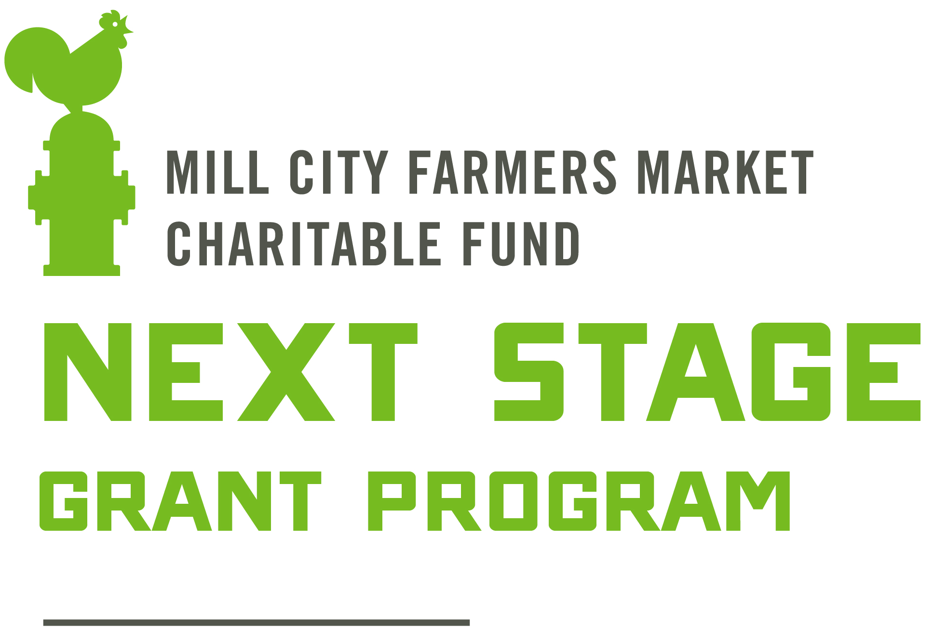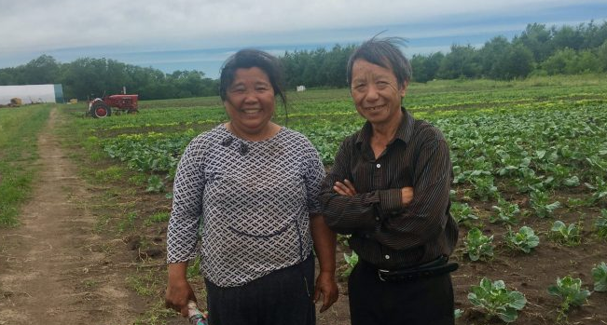

Grant for Farmers & Food Makers

Mill City Farmers Market Charitable Fund (MCFM-CF) is committed to the success and sustainability of the local food community. MCFM-CF’s Next Stage Grant is designed to provide funding to local farmers and food makers who are improving sustainable farming and business practices and growing toward the “next stage” of their businesses.

Next Stage Grant Program Details

Grants are typically between $1,000 and $7,000

Grantee requirements:
- Farm or business must sell at one or more regional farmers markets.
- Farm or business is located in Minnesota or western Wisconsin
- Farm practices sustainable growing techniques or food maker sources from sustainable growers OR the grant project brings you closer to doing these things

Grant projects can include (but are not limited to):
- Transition to organic certification and other regenerative farming and land management practices
- Building cold storage facilities
- Season extension projects
- Training, courses and other forms of continuing education specific to your business

The following may also be funded, but are subject to financial need and hardship:
- New product development such as value-added farm goods or diversifying crops or livestock
- Software and other technology upgrades such as heaters, refrigerators, solar installations and business management software
- Marketing improvements such as labeling and packaging equipment or web design

Grant applications are due on March 1st, 2025. For more details and applications instructions, please review our Next Stage Grant Description and Application on our website:

millcityfarmersmarket.org/grants

You can contact us with questions at: info@millcityfarmersmarket.org or 612-341-7580

