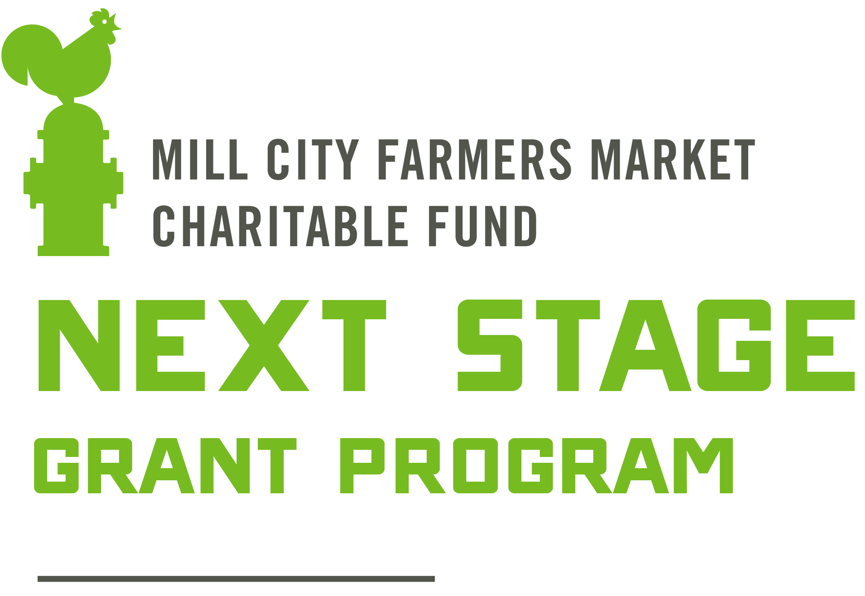

The Mill City Farmers Market Charitable Fund (MCFM-CF) is committed to the success and sustainability of the local food economy. MCFM-CF designed the Next Stage Grant to provide funding to local, regenerative farmers and other food makers who are improving sustainable farming and business practices or growing toward the “next stage” of their local food businesses. MCFM-CF also offers grants for farmers who experience hardship (see Hardship Grant application). These programs are sustained through the generosity of the market community.

The Next Stage Grant program embodies MCFM-CF’s commitment to building a healthy, local and sustainable food economy and is rooted in our educational mission. The goal of this grant program is to help keep small market farmers on the land, producing nourishing food for all. We also strive to foster a shared learning community with grant projects. Therefore, we expect grantees to work with MCFM-CF staff to share learnings from their projects to grow the health of our local food system.

Application Process:
This grant is meant to be easily accessible for busy, hardworking farmers and small business owners. MCFM-CF staff is available to answer your questions, help you complete the application and will gladly provide translation services. MCFM-CF staff is also available to provide guidance on grant design and connect applicants to potential mentors and/or technical assistance. Moreover, if a grant is awarded to your project, MCFM-CF can assist grantees review, summarize and create outreach material based on their project findings. For questions or assistance with your application, please contact us at info@millcityfarmersmarket.org or 612-341-7580.

Applicant Requirements:
- Farm or business must sell at one or more regional farmers markets. Preference will be given to applicants with a higher percentage of sales coming from direct-to-consumer sales.
- Farm or business must be located within 200 miles of Minneapolis or in Minnesota
- Farms and businesses must adhere to Mill City Farmers Market’s Sustainability Statement or the project must aim to bring them closer to meeting it.
- Farm or business must have been in operation for more than one year
- Not required to be a current vendor at the Mill City Farmers Market
- Farms structured as 501(c)3 nonprofits are eligible to apply as of 2022
- Current members of MCFM-CF’s Next Stage Grant Program Selection Committee and their family are not eligible to participate in the Next Stage Grant Program
MCFM-CF will not fund:
- Mere underwriting of farming operations, including the purchase of depreciable property (e.g., tractors, implements, large machinery) unless there is an educational, research or alleviation of poverty component
- The cost of business, for example: permits, licenses, product labels, replacing greenhouse plastic and general maintenance
- Pre-existing debt
- Any project that does not fall within MCFM-CF’s charitable purposes as a tax-exempt organization under Section 501(c)(3) of the Internal Revenue Code

Next Stage Grant program uses can include (but are not limited to):
- Support farmer transition to organic certification and other sustainable and regenerative farming and land management practices
- Training, courses and other forms of education related to capacity-building and sound business practices from professional service providers or qualified consultants (Other farmers or business owners, marketing specialists, web designers, etc.)
- Innovations that improve efficiencies, growing practices or product quality

The following may also be funded, but are subject to additional criteria relating to financial need and hardship situations defined by MCFM-CF’s ‘Financial Need Statement’:
- Building cold storage facilities
- Season extension projects
- New product development such as value-added farm goods, diversifying crops or livestock, etc.
- Software and other technology upgrades such as heaters, refrigerators, solar installations, business management software, etc.
- Marketing improvements such as labeling and packaging equipment, web design, etc.

Grantee Expectations:
- Grantees must submit a mid-season check-in in by early August and final outcomes in January
- Grantees will share their findings at MCFM-CF’s annual grant education event, educating other farmers, makers and the local food community about the outcomes of their projects.
- MCFM-CF may ask grantees to contribute to future Next Stage Grants through grantee mentorship or serving on the grant review committee
- Grantees must proactively communicate any significant changes in their projects or scope of work

Evaluation
MCFM-CF’s Grant Review Committee (made up of MCFM-CF board members and staff, local farmers and food makers, former grant recipients and other local food community leaders) reviews grants based on the following criteria: project design, budget and transferability.

Grant Amount & Timeline
Grants are typically between $1,000 and $7,000. This grant will result in taxable income to be reported on a 1099. Applications are due March 1, 2023. Grants will be awarded in early April 2023.

Application available at millcityfarmersmarket.org/grants/

2023 Application
Name:
Phone Number: Email:
Farm/Business Name: Year Established:

Business Structure:
☐LLC
☐Sole Proprietorship
☐Cooperative
☐Partnership
☐501(c)3 Nonprofit
☐Other:

If business is owned by multiple parties, please describe. Who are additional parties and what is percent ownership of each?

Farm/Business Address:

Mailing Address, if different:

Farmers, please note whether you own or rent your land and the length of lease if applicable:

Short description of your farm or business:

Grant Project Name:

Short description of your Next Stage Grant project:

Grant Request (no more than $7,000): $

Project Goals:
What do you hope to achieve with this project? Please list one to three specific goals.
1.
2.
3.

Describe the role of sustainability in your business, including any relevant certifications (USDA Organic, Certified Naturally Grown, etc.) or describe your agricultural, land management and/or sourcing practices.

Tell us about your journey into farming or business ownership. What is your previous experience in this industry? Be sure to note if there is an immigration story or other relevant information.

Where do you sell your products? Please be specific with market names when applicable.

What percentage of your sales come from farmers markets? %
From other direct marketing? (CSA, on-farm sales) %
From wholesale or other outlets? (Restaurants, co-ops, schools) %
=100%

Do you or members of your household work off-farm jobs? What percentage (%) of your income is from your farm or other business? (Please use your adjusted gross income from your most recent tax return).

What percentage (%) of labor do you contribute to your farm or other business? Who else contributes to the success of your farm or business?

Project Rationale:
How does this project fit into the larger picture of your businesses? How does it bring your farm or other business to the “next stage”?

Project Design and Methods:
What are you going to do? Describe in detail how you will complete your project from beginning to end. Be as specific as you can and attach drawings or diagrams as needed.

List the research you have done to prepare for this project.

Please include any relevant market analysis, especially if you are expanding or diversifying products (Is there demand for the product?).

We encourage applicants to work with experts for technical assistance wherever applicable. Are you seeking guidance, mentorship or technical assistance from a relevant specialist, extension agent, or other farmer or business owner who has tried a similar project? If so, who?

If you would like mentorship on this project but do not have someone to work with yet, please make a note here. MCFM-CF staff and the grant committee can help connect you with someone with relevant expertise.

Timetable for completion of this project:

Evaluation:
For each of the project goals you listed above, what information will you collect to determine whether your project is successful and whether you would recommend it to other farmers or business owners? Be specific.

Outreach & Education:
Do you see your project benefitting your community and the broader local food system? If so, in what ways?

In addition to working with MCFM-CF staff to distribute information about your project, how might you share what you learn so others can benefit from your work? For example: Might we be able to assist you complete an article for a newsletter? Might you be willing to speak at meetings or conferences? If you have a website, could you consider posting information on it?

How did you find out about the Next Stage Grant Program?
☐Word of mouth from a former grant recipient
☐Facebook or Instagram
☐Email from Mill City Farmers Market
☐From another organization (SUSTAG listserv, HAFA, SFA chapter, conference, etc.):
☐Other:
☐Don’t remember

Budget:
Grant funding requested (no more than $7,000): $

Total Project budget (including grant dollars requested): $

If applicable, how will you fund the remainder of the project? (ex. self-funding, other grants, bank loan, etc.) Please note whether additional funding sources are secured or pending.

What will you or your business contribute to the project? Applications are evaluated based on the applicant’s investment in the project, appropriate for the size of the business and risk of the project. Please be clear about your financial contribution and/or labor “sweat equity” involved in the project.

Have you received a Next Stage Grant from MCFM-CF in the past? If so, when?

You will need to submit a detailed project budget and a completed copy of the NSG Financial Summary spreadsheet with this application. Find both at millcityfarmersmarket.org/grants

Optional Demographic Information:
MCFM-CF is committed to supporting farmers and makers who have experienced institutional barriers to economic opportunity. Please take a moment to complete the following demographics questions.

NOTE: Providing this information is not required; however, completion of this section of the application may result in additional points being added to the total score and therefore influence whether a grant is approved. We are asking for this personal and private information to create more equity in our process; this information will be shared with the NSG nominating committee only.

What are your preferred pronouns?
☐He/him
☐She/her
☐They/them
☐Prefer not to answer
☐Other:

How do you identify yourself? (Select all that apply)
☐Asian
☐Black, Afro-Caribbean or African
☐Latinx or Hispanic
☐Native American
☐White or European
☐Prefer not to answer
☐Other race, ethnicity or origin:

Including children and other dependents, how many persons were in your household in 2022?

What was your 2021 Adjusted Gross Income? (from your most recent Form 1040 of U.S. Federal Tax Return)

Please feel free to share other demographic information that illustrates your identity or share an example or story of how you have experienced economic challenges based on your identity.

Confirmation
Please sign, e-sign or type your name below, confirming all information in this application, project budget and financial summary are accurate to the best of your knowledge.

Signature:

Application Checklist:

Signed & Completed Application (pages 3-6 of this document)
Detailed project budget
Completed NSG Financial Summary

Email completed application to info@millcityfarmersmarket.org by March 1st, 2023. Contact us at 612-341-7580 or info@millcityfarmersmarket.org if you would prefer to submit your application through the mail.

GP:4810-8485-1290 v2

Our goal is to focus on farms or businesses who do most of their business as direct-to-consumer sales, which are defined as goods sold directly from producers to individuals, for example: farmers markets, CSAs and on-farm sales.
The Next Stage Grant program gives preference to small farms owned by individuals, since they often have fewer resources and grants available to them compared to nonprofit organizations. However, we also recognize the important role nonprofits play in supporting farmers, especially farmers who have been marginalized and/or denied access to capital. When assessing applications from nonprofits, we review budget size of organization, fundraising ability and size of farm among other applicant considerations.
“Family” for these purposes includes an applicant’s spouse; siblings; children; grandchildren; great grandchildren; the spouses of siblings, children, grandchildren, and great grandchildren; parents; grandparents; and other ancestors.
MCFM-CF believes strongly in interrupting the cycle of poverty for farmers across America. Please review our Financial Need Statement for more information about funding projects that have the potential to increase income on your farm.

