Mill City Farmers Market Contact:
Jenny Heck, Marketing and Events Manager
jenny@millcityfarmersmarket.org, (763) 308.3662
www.millcityfarmersmarket.org
May 1, 2019
FOR IMMEDIATE RELEASE:
Mill City Farmers Market Opening for 2019 with new Sustainability Statement
The Market’s new policy attests to its reputation as a trusted grocery source and local food leader.
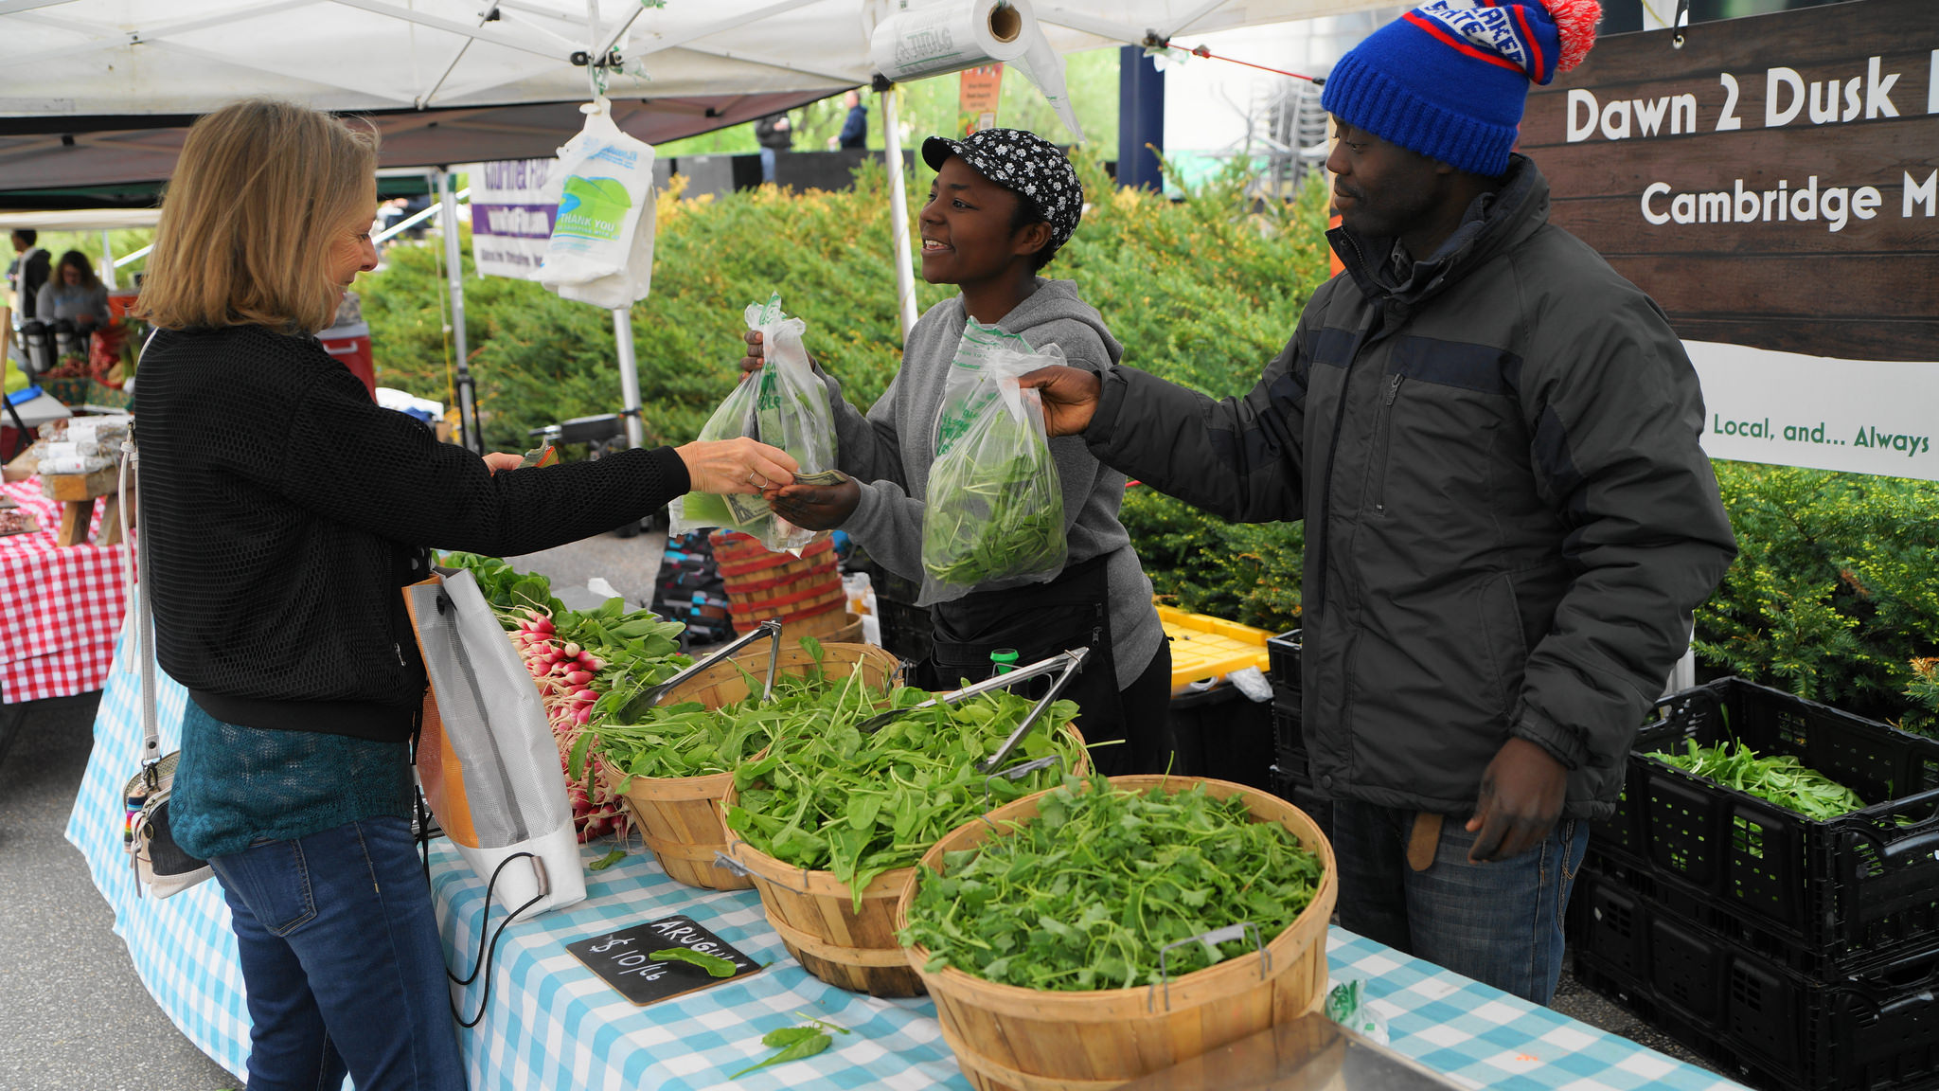
Minneapolis, Minn.—On Saturday, May 4th from 8 a.m. to 1 p.m. the Mill City Farmers Market (MCFM) will open its outdoor season, located in downtown’s East Town neighborhood, with a renewed dedication to its motto “healthy foods, local farmers.” For its 14th season, the Market has added a “25% Local Standard” to its existing Sustainability Statement, which the Market requires all 104 farmers, makers, food trucks and other small business owners who vend there to follow.
The new rule states vendors selling value-added foods, baked goods and prepared food must use a minimum of 25 percent local ingredients, preferably sourced directly from MCFM agricultural vendors. MCFM defines local as a 250-mile radius from the market.
Many vendors have always practiced this policy and go even further by sourcing nearly all of their ingredients from local farmers. You Betcha Kimchi, owned by husband and wife team Joe Silberschmidt and Iman Mefleh, started vending at MCFM in 2017. The duo’s makes a tasty Minnesota-take on kimchi, using only local vegetables.
“After a year of growing many of the veggies ourselves, we’ve now found local sources for all our vegetables, even our ginger, and have built on strong partnerships with Minnesota and Wisconsin organic farms,” explains Joe.
Stories like this exist throughout the market. Breakfast vendor Black Cat Natural Foods buys an impressive 90 dozen eggs from neighboring vendor Sunshine Harvest Farm each week for their signature McDonner egg sandwich, omelets and pulled pork hash. Serious Jam uses local, seasonal fruit for unique creations such as ground cherry and crab apple preserves. And, of course, there are many farmer makers who use their own farm products to make unique additions for your grocery basket, such as: mushroom butters, goat milk caramel sauce, garlic scape pesto and medicinal herbal teas.
MCFM has championed for the local food movement and put farmers first since its founding in 2006 by farm-to-table pioneer and James Beard nominated restauranteur Brenda Langton. While not all of its vendors are USDA Certified Organic, they all adhere to the Market’s Sustainability Statement, which, in addition to the new 25% Local Standard, supports healthy soils, sustainable water use, humane treatment of livestock, honorable workplace practices and rejects synthetic inputs and GMO seed. As of 2018, MCFM farmers support 1,255 acres of sustainable farmland and its vendors generate an estimated 2 million dollars into the local economy each year, according to University of Minnesota research.
The Market is asking its makers and prepared food vendors to support local and sustainable farmers not only because of their superior quality and freshness, but also because they don’t externalize costs onto the environment, our community’s health or through poor wages and working conditions for their staff and themselves. MCFM believes supporting local farms nurtures healthier use of our land and limited resources, fuels our local economy and provides safer, more nutritious food for you and your family.
On top of MCFM’s new policy further cementing its commitment to the local food community and to loyal, long-term vendors, it is also introducing several exciting new vendors for the 2019 season:
- Autumn Higgens Ceramics, handmade functional porcelain
- Green Light Farm, fresh-cut tulips
- Jen’s Jars, small-batch vegan soups and spreads
- Maat Mons, canvas bags and soft goods
- Maazah Chutney, family-made Afghani green sauce
- Star Thrower Farm, Icelandic sheep fiber
- Twin Cities Berry Company, season-extended, MN-grown strawberries July through October!
Additionally, regular MCFM shoppers will be happy to hear that in the face of recent downsizing, beloved vendors Salty Tart bakery and Chef Shack food truck will both be returning to the Market full time in 2019.
Mill City Farmers Market is Minneapolis’ trusted source for healthy, local and organic groceries, bringing a wide assortment of fresh food, cooking education and live entertainment to one beautiful place. Located next to the Guthrie Theater on 2nd Street S. and Chicago Avenue in Minneapolis’ East Town neighborhood, the market runs every Saturday May through October from 8 a.m. to 1 p.m. Learn more at millcityfarmersmarket.org.
###

